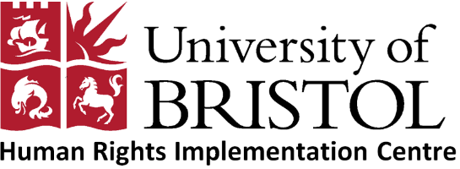

Opportunity to teach law at the University of the Gambia
We are writing to let you know of an exciting opportunity to teach law at the University of Gambia. The Faculty of Law at the University of Gambia is seeking an individual to teach law during its next academic year, which commences in September 2019.
Applicants must have completed and passed Part 1 of their LLM or MSc, or be finishing the second year of their MA, or be studying for a PhD, and be willing to teach first, second or third year law students core law subjects. The University of also looking for those who may have a particular interest/experience in Clinical legal education or library and books management. However, you should also be willing and able to teach other subjects such as jurisprudence, law of tort, law of contract, constitutional law, public international law, international criminal law, legal reading and writing, mooting, legal method and international human rights.
The academic year runs from September 2019 to mid-May 2020.
The University of Gambia will pay a local salary and will arrange accommodation close to the University. The University of Gambia will also arrange the necessary permits when you arrive in order that you may work at the Law Faculty.
The Human Rights Implementation Centre will be able to cover the cost of one economy return flight to the Gambia from the UK for the successful candidate, as well as annual insurance and a set amount towards vaccinations.
The Faculty of Law at the University of Gambia is still in its infancy and therefore you must be prepared to develop the law course, set and mark exam and essay questions and generally to work in an environment with more limited facilities than you may be used to.
This is a unique opportunity to be part of the country's first attempt to create a home-grown legal community.
A former University of Bristol Law Student who took on this role at University of Gambia comments:
‘Teaching at the UTG has provided me with a huge amount of responsibility and experience in a short amount of time. As a lecturer, I have directed units on Tort law, Jurisprudence and Public International law. This has involved planning a syllabus and delivering lectures, as well as giving and marking assessments. Although often working in a challenging environment, in different cultural circumstances and with lack of resources, teaching in The Gambia is very rewarding. Additionally, beyond teaching there is opportunity to get involved with organising other activities at the UTG Faculty of Law, for example, the Law Clinic, mooting, or the Law Review.
Living in The Gambia is also very interesting, experiencing an entirely different culture and people in which you can almost entirely immerse yourself’.
If you would like to be considered for this opportunity then please send a letter addressing the six questions set out below together with a copy of your CV to Paige Spicer by Wednesday 22nd May 2019. Interviews for shortlisted candidates will take place w/c 3 June 2019.
Thank you.
Rachel Murray (HRIC Director) and Debra Long (HRIC Research Associate)

QUESTIONS FOR THE UNIVERSITY OF GAMBIA OPPORTUNITY
- Why do you want this position?

- What are the possible challenges you could face if you were to teach at the University of Gambia? How would you overcome these?

- What do you think makes a good lecturer and why?

- How would you approach developing the curriculum and setting exams for the Law Faculty? What issues would you need to consider?

- Tell us about your experience of working with the UOB Law Clinic/Human Rights Law clinic.

- Have you had any experience of either travelling or working abroad? If so are there any aspects of this you could apply to this position?

- What would you like to do after this experience?

